HOTEL RESERVATION REQUEST
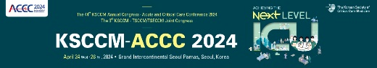 21st ~ 26th April, 2024

Reservation Dept. Tel. +82 2 500 2302 Fax. +82 2 500 2311 Email: rsvn@uri-nhotel.com

- Please complete this form and return directly by fax or email to us no later than 30 days prior to your arrival to ensure room availability and special discount.

Hotel | Room Type | Room Rate | Bed Type | Benefit
URI& | Superior Double  (17Q.M) | KRW 140,000 |  | 2 bottles of Water  Wired & Wireless
 | Superior Twin  (17Q.M) | KRW 160,000
1. Hotel Reservation:

- The above special rates are subject to 10% VAT.
- Check-in time is 15:00, Check-out time is 11:00.
- Breakfast is temporarily unavailable.
- Reservation may not be available depending on the reservation status.

2. Participant Information:
Last Name(Prof,Dr,Mr,/Ms) : | First Name :
Arrival Date : | Departure Date : No later than 26th of April, 2024
Company Name / Country : | Email :
Phone : | Fax :
Address :
Flight Number (if known) :

3. Booking Guaranteed:
Card Type : | Name on Card :
Card No. :
Signature : | Exp. Date : ( / / )

- Cancellation Policy: Should you wish to cancel or modify the booking, you will need to advise the hotel 2 days prior to the arrival date to avoid a cancellation penalty of 1 night of accommodation fee.
- Full night room rate will be charged to your credit card if you cancel on the arrival date or No-show.

